MARKING SCHEME
Secondary School Examination 2023
SCIENCE (Subject Code–086) [ Paper Code:31/1/3]
Maximum Marks: 80

Q.  No. | EXPECTED ANSWER / VALUE POINTS | Marks | Total Marks
 | SECTION—A | 1 | 1
1. | (a) | 1 | 1
2. | (b) | 1 | 1
3. | (b) | 1 | 1
4. | (c) | 1 | 1
5. | (c) | 1 | 1
6. | (c) | 1 | 1
7. | (a) | 1 | 1
8. | (d) | 1 | 1
9. | (d) | 1 | 1
10. | (c) | 1 | 1
11. | (d) | 1 | 1
12. | (a) | 1 | 1
13. | (a) | 1 | 1
14. | (d) | 1 | 1
15. | (c) | 1 | 1
16. | (c ) | 1 | 1
17. | (c) | 1 | 1
18. | (a) | 1 | 1
19. | (a) | 1 | 1

20. | (b) | 1 | 1
 | SECTION B
21. | - Auxin  - When light is coming from one side of the plant, auxin diffuses towards the shady side of the shoot. This stimulates the cells  of the shoot to grow longer and bend towards light. | 1  1 | 2
22. | - (i) X: Plaster of Paris/Calcium sulphate hemihydrate.  - CaSO4. 1 H2O  2  - • Baking Soda – NaHCO3 /Sodium hydrogen carbonate/  Sodium bicarbonate  - Baking Powder – A mixture of NaHCO3 /Baking soda +  Tartaric acid/any mild edible acid  OR  (b) (i) CuSO4. 5H2O ⎯⎯hea⎯t⎯→ CuSO4 + 5H2O  (ii) 2NaHCO3 ⎯⎯hea⎯t⎯→ Na2CO3 + H2O + CO2 | ½  ½  ½  ½  1  1 | 2
23. | - Kidneys  - Structure: A cluster of thin-walled capillaries (glomerulus) associated with cup-shaped end of a tube called Bowman’s capsule. This further extends into a tubular part which ends in collective ducts. /  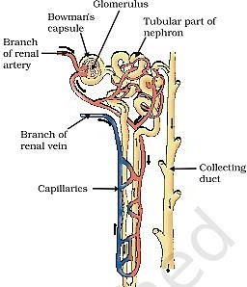  - Function: | ½  1  ½

 | Filtration of nitrogenous waste from blood to form urine. / Reabsorption of useful materials from the filtrate. / Osmoregulation (Any one function) |  | 2
24. | - Lead and Tin / Pb+Sn  - Low melting point | 1  1 | 2
25. | •UV rays reach the earth and cause ill effects like skin cancer  in human beings.  - (a) Minimize the use of CFC’s  (b) Forging on agreement to freeze CFC production at 1986 levels. | 1  ½  ½ | 2
26. | (a)  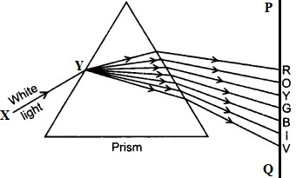  - Dispersion of white light  - Cause: Different colours of light bend through different angles  w.r.t. the incident ray. / Different colours have different wavelengths.  OR  - (i) It is due to gradual weakening of the ciliary muscles and diminishing flexibility of the eye lens.  - Presbyopia/ Presbyopia + Myopia  - Bifocal /Concave + Convex lens/ Diagram  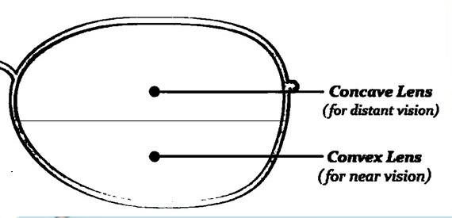 | 1  ½  ½  ½, ½  ½  ½ | 2

 | SECTION C
27. | - Na2CO3.10H2O / washing soda / sodium carbonate decahydrate  - NaCl + H2O + CO2 + NH3 →NH4Cl + NaHCO3  2NaHCO3 ⎯⎯hea⎯t → Na2CO3 + H2O + CO2 Na2CO3 + 10H2O → Na2CO3.10H2O  - 10 | 1  ½  ½  ½  ½ | 3
28. | - (i) NH3  - H2O  - CO  - H2  (Award full mark if part (ii)of (a) is attempted)  - A reaction in which the gain or loss of oxygen takes place simultaneously is called a redox reaction. | ½  ½  ½  ½  1 | 3
29. | - Concave Mirror / Converging Mirror  - (i). m = - v = - (- 60 ) = - 4  u (- 15)  (ii). 45 cm from the object  (c)  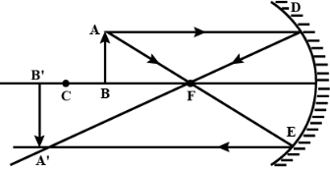  (Note: ½ mark to be deducted for not drawing the arrows.) | ½  ½+½  ½  1 | 3
30. | - (i) Energy currency for cellular processes / ATP breaks down to give a fixed amount of energy which can drive the endothermic reactions taking place in the cell.  - Stomata and surface of leaves, stems and roots.  - Environmental conditions Requirements of the plant.  OR  - (i) Plants -Starch  Animals- Glycogen  - Desert plants take up carbon dioxide at night and prepare an  intermediate compound which is acted upon by the energy absorbed by the chlorophyll during the day. | 1  1  ½  ½  1  1  1 | 3
31. | (a) (i) Flemings left-hand rule:

 | Stretch the forefinger, the central finger and the thumb of your left hand in mutually perpendicular directions. If the forefinger shows the direction of the magnetic field and the central finger that of the current, then the thumb will point towards the direction of motion of the conductor or direction of force /  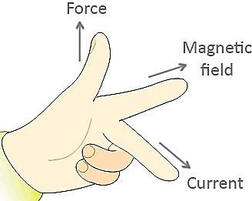  (ii) (1) Force on electron is maximum in Fig (i) because the direction of motion of electron/current is at right angle/perpendicular to that of magnetic field.  (2) Force on electron is minimum in Fig (iii) because the electron is moving along / parallel to the direction of magnetic field  OR  (b) (i) (1)  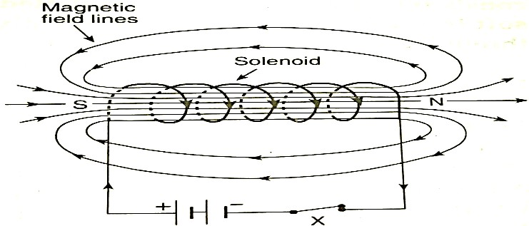  Magnetic field lines of a current carrying solenoid  (2)  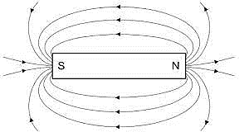  Magnetic field lines of a bar magnet | 1  ½,½  ½,½  1  1

 | (ii)  (Any two) | ½+½ | 3
32. | - (i) Kitchen Garden → A man made ecosystem / non-sustainable  Forest → Ecosystem maintained by nature / self-sustainable (ii)In a jar containing water we can provide oxygen through a pump  and add a few aquatic plants and animals to make it a self- sustaining system.  Justification –  - Oxygen is replenished continuously.  - Aquatic plants serve as food.  (or any other example)  OR  - (i) Plants ⎯⎯→ Rats ⎯⎯→ Snakes ⎯⎯→ Hawks  (ii) Energy available at second trophic level = 20,000 J  Energy transferred from second to third trophic level = 2000 J Energy transferred from third to fourth trophic level = 200 J | 1  1  1  1  1  1 | 3
33. | - Myopia / Short Sightedness  - ​  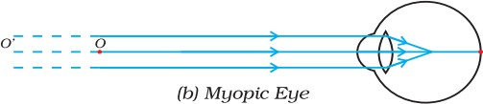  - Two Causes :  - Excessive curvature of the eye lens  - Elongation of eye ball  - Concave lens / Diverging lens | ½  1  ½  ½  ½ | 3
Magnetic field of a solenoid | Magnetic field of a bar magnet
1. The strength of the magnetic field can be changed by changing the current. | 1. The strength of the magnetic field for a bar magnet cannot be changed.
2. The direction of magnetic field can be reversed by reversing the direction of current. | 2. The direction of magnetic field for a bar magnet cannot be changed.
3. It is a temporary magnetic field. | 3 It is a permanent magnetic field.

 | SECTION D
34 | (a)  - Testis – To produce male gametes/sperm/Male hormone/Testosterone  (Any one).  - Scrotum – To provide optimal temperature to testis for the formation of sperm.  - Vas deferens – Transport the sperm to urethra.  - Seminal vesicles – To secrete the fluid which provides nutrition and  medium for the transport of sperms.  (b) Placenta – A disc shaped specialized tissue embedded in the uterine wall which connects the mother to the embryo. It contains villi on the embryo’s side and blood spaces on the mother’s side.  Function: – Helps in exchange of nutrients, gases and waste materials between the mother and embryo/foetus. | ½  ½  ½  ½  2  1 | 5
35. | - When heating is at maximum rate. Power, P = 880 W  Voltage, V = 220 V  Current, I = P = 880 = 4A  V 220  Resistance, R = V = 220 = 55 Ω  I 4  When heating is at minimum rate Power, P = 330W  Voltage, V = 220 V  Current, I = P = ³³⁰ = ³ =1.5A  V 220 2  Resistance, R = V =²²⁰ =146.6 Ω  I 115  - When electric current is passed through a resistor, electrical energy is dissipated and appears as heat energy.  - H = I2Rt/ H=VIt | ½,½  ½,½  ½  ½  1  1 | 5
36. | - (i) A: CH3CH2OH / Ethanol / Ethyl alcohol B: CH2 = CH2 / Ethene  C: CH3 - CH3 / Ethane  (ii)  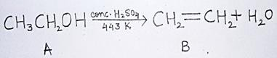 | ½  ½  ½  1

 | - Carbon dioxide and water are produced and a large amount of heat is released /  C2H6 + O2 → 2CO2 + 3H2O + Heat  (Award full marks even if equation is not balanced.)  - Conversion of vegetable oil into fats.  - Sodium ethoxide and hydrogen  OR  (b) (i)  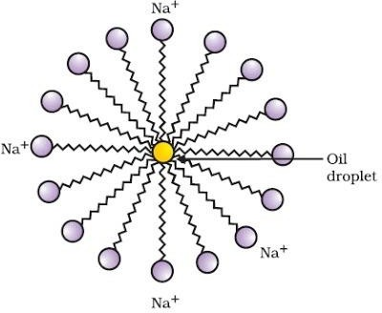  - (1) • Test tube ‘Y’.  - Detergents are effective in hard water.  (2) • Test tube ‘X’  - Reaction between soap and calcium and magnesium salts of hard water form insoluble scum / due to formation of scum / insoluble ppt. | 1
 |  | ½
 |  | 1
 |  | 2
 |  | ½,1
 |  |  | 5
 |  | ½,1
37. | - Tall – Dwarf (Height of plant)  White – Purple (Colour of flower) (or any other)  - Dominant Trait – are expressed even if one copy of dominant trait exists.  Recessive Trait – Whose expression is suppressed by a dominant  gene/ Expressed when two copies of recessive traits are present.  - 9 : 3 : 3 : 1  Interpretation: Traits are independently inherited.  OR  (c)
 |  | ½,½
 |  | ½
 |  | ½
 |  | 1
 |  | 1

 | 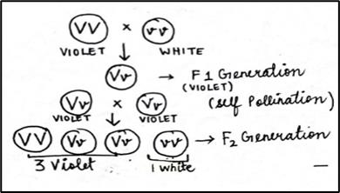  (or with punnet square diagram) | ½×4 | 4
38. | - Torches, search light, vehicles head lights, shaving mirrors,  dentist’s mirror, Solar furnaces. (any two)  - f = 15cm R = 2 f  R = 2 × 15 cm = 30 cm  - ​  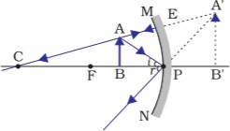  (Note: ½ mark to be deducted for not drawing the arrows.)  OR  (c)  (i) h = + 10cm u = - 100 cm v = - 100 cm  1 + 1 = 1  𝑣 𝑢 𝑓  - ¹ - ¹ = = ¹  100 100 𝑓  −2 = 1  100 𝑓  f = -50 cm  Alternate answer for (i)  Since u = v  Therefore, object is placed at centre of curvature (C)  f = ^{𝑅}  2
 |  | ½+½
 |  | ½
 |  | ½
 |  | 2
 |  | ½
 |  | ½

